 |    | 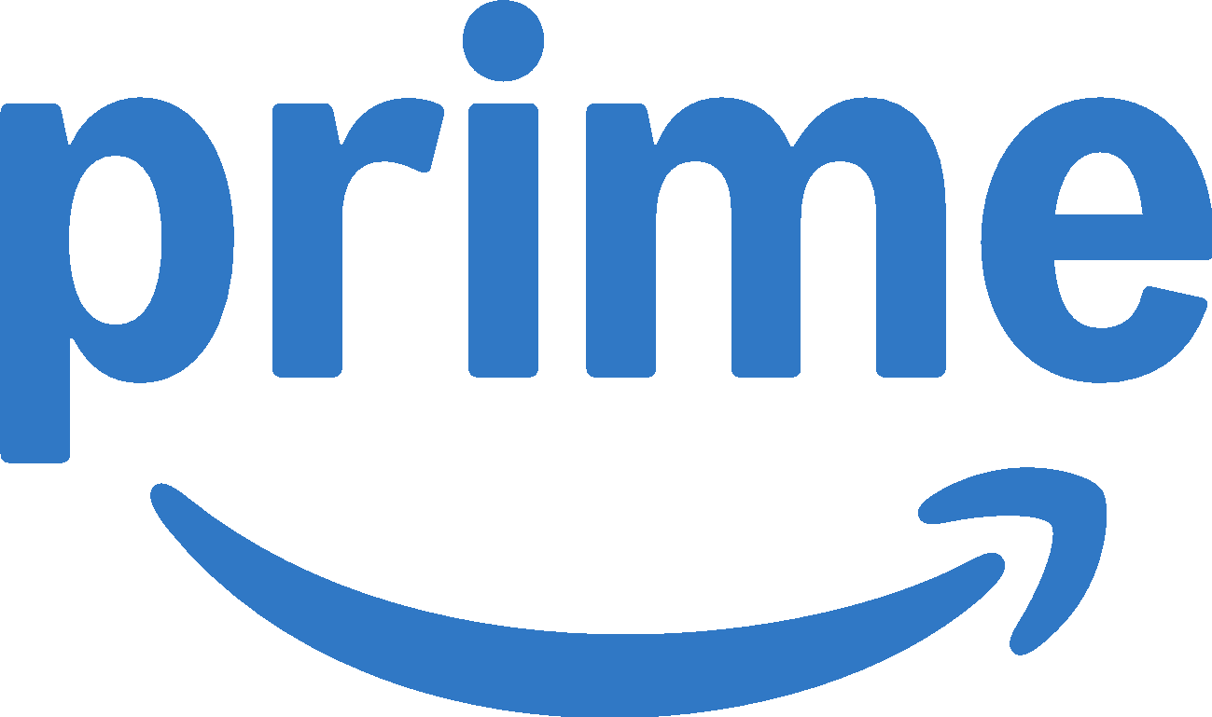
 | Entry Form Template
This document serves as a guide to help you through the entry process. Use this template while crafting your submission to enable easy collaboration with team members. Copy & paste your answers to the questions below in the Entry Portal. All entries must be submitted via the Entry Portal. A PDF of your entry will be available after submission. The answers provided on this form will be evaluated by judges.

ENTRY DEADLINE: APRIL 2, 2025

ENTRY TIPS  - CLIENT BRIEF: Refer to the client brief for specific challenge requirements and parameters, in addition to pertinent background information. The brief can only be accessed after a Non-Disclosure Agreement has been submitted.  - BREVITY: Be clear, concise, and compelling. Shorter, well-written entries typically stand out, as judges are reviewing numerous entries.  - SPEAK TO THE BRAND CHALLENGE: Make sure that you effectively address the brand challenge and provide solutions that directly respond to the challenge.  - TELL A STORY: Judges are looking for an engaging, well-written, consistent story that links each section of the form together. Before you start your entry, write a brief summary paragraph and determine how the sections connect. Then, begin to provide further details and answer the specifics of each question.  - REVIEW: Before submitting, proofread your case for grammar, spelling, punctuation, etc. Review all requirements from the client brief to ensure you have responded to all parts of the challenge.  Review more advice on crafting your submission in the  Effective Entry Guide. |  | FORMATTING & ENTRY REQUIREMENTS  - PRIMARY RESEARCH: At least two primary research sources are required. All claims/facts presented must be sourced using footnotes.  - WORD LIMITS: Because each entrant has a different story to tell, word limits are kept broad. However, you are not required or encouraged to utilize all space provided.  - CHARTS & GRAPHS: You are encouraged to display data via charts & graphs within the limits allotted in each question. To insert charts & graphs in your responses in the Entry Portal, save each chart/graph individually as a .jpg image (700-900 pixels wide or tall recommended).  - NO PICTURES/SCREENGRABS: Do not include images of your creative work or other images, including social media screenshots, in the written portion of your entry.  - NO EXTERNAL LINKS: Do not direct judges to external websites – judges can only review the content provided in your written entry and creative examples.  - CREATIVE ASSETS: Brand logos, and all creative assets provided, are only to be used for the purpose of this competition. Creative executions should only be viewed by team members, focus groups, faculty/professors, etc. Public distribution of creative executions that include branding elements will result in automatic disqualification.

ENTRY FORM TEMPLATE
All questions are required. Responses will be evaluated by judges.
Additional data, not seen by judges, is required in the Entry Portal to submit. Please begin working in the Entry Portal in advance of the entry deadline.
ENTRY DETAILS
TEAM NAME
Create a name for your team that will be used for publicity purposes if your case is a finalist or winner.
ENTERING SCHOOL | Northwestern University
ENTRY TITLE  Provide a campaign title that captures the essence of your work. | Your Prime, Your Way.
BRAND / CHALLENGE | AMAZON
ENTRY ID#  Your Entry ID# is obtained once you have started your entry in the Entry Portal. | E-817-387

ENTRY SUMMARY
Why is this the best solution to the marketing challenge presented by Amazon? Why is this entry worthy of being presented to the brand team?
(Maximum: 100 words)
Provide your answer.
Our approach repositions Prime from a passive utility to an enabler of Gen Z’s self-expression. Algorithm-driven platforms claim personalization but often misrepresent users, distorting their digital identity with family accounts or irrelevant browsing history. This frustrates Gen Z, who value individuality and control. By exposing these moments—feeds hijacked by a sibling’s anime obsession or a parent’s shopping habits—we position owning Prime as the solution for reclaiming self identity and autonomy. Platform-native creative and disruptive placements reinforce this message, while a robust measurement framework tracks perception shifts, engagement, and subscription growth, making this strategy a compelling case for Prime’s repositioning.
Give the judges an understanding of the entry they are about to read by providing a one-sentence summary for the below sections.
(Maximum per line: One Sentence – 20 words.)
Challenge: | Amazon Prime feels like a utility to Gen Z, not an aspirational brand, requiring a repositioning that highlights personalization and user control.
Insight: | Gen Z seeks partnership, not prescription—they want brands to empower their self-expression and control over their own experiences, not dictate them.
Strategic Idea/Build: | Empower Gen Z with the freedom to personalize and control, seamlessly integrating Prime into their lives—on their terms, not ours.
Bringing the Strategy & Idea to Life: | Our campaign exposes frustrations of algorithm-driven recommendations, positioning Prime as the solution for Gen Z to reclaim personalization and control.
Measurement Methodology: | We will track brand perception, engagement shifts, and subscription growth through surveys, social listening, A/B testing, and conversion analysis.

SECTION 1: CHALLENGE, CONTEXT & OBJECTIVES
25% OF TOTAL SCORE
This section provides the judges with the background to your challenge and objectives. In this section, judges evaluate whether they have the necessary context about the industry category, competitors, and brand to understand your entry and the degree of challenge represented by your objectives.

1A. CHALLENGE & CONTEXT  What are the specific challenges/opportunities that the brand faces? Provide information on the category/marketplace, brand, competitive environment, and/or the product/service that created your challenge and your response to it. Be sure to provide a competitive context.  (Maximum: 275 words; 3 charts/graphs) | Effie Tips:  - The strategic challenge is the glue that shapes the other elements of the entry and should be clear to understand.  - Provide context about the degree of difficulty of this challenge.  - Strategically address the marketing challenge outlined in the brief; this is a key piece in defining the problem.  - Go deeper than restating what was provided in the client brief.
Provide your answer.
Amazon Prime struggles to connect with Gen Z, a generation that values autonomy, self-expression, and control. While widely recognized for practicality and convenience, Prime is often seen as a functional tool rather than an aspirational brand. This perception is reflected in our survey, where respondents associated Prime with words like fast (39 mentions), efficient (15), and convenient (12), while aspirational, personal, and empowering received zero mentions (Chart 1). Gen Z doesn’t want brands dictating their choices—they seek platforms that let them shape their own experiences. Though Prime offers personalization features like custom watchlists, it has yet to position itself as a platform that fosters autonomy.
In the competitive marketplace, Prime competes with subscription services such as Netflix, Spotify, and YouTube, which embed themselves in Gen Z’s cultural identity by enabling self-expression through entertainment and discovery. Meanwhile, platforms like TikTok and Instagram give Gen Z direct control over content and curation, making Prime feel more like just another utility or transactional service rather than a brand that enhances self-expression.
To resonate with Gen Z, Amazon must reposition Prime from passive utility to active empowerment. The key challenge is reframing Prime’s communication strategy to emphasize autonomy and self-control. Instead of emphasizing convenience, the campaign should showcase Prime as an enabler for Gen Z to take charge of their own lives—whether through personalized recommendations, curated playlists, or custom watchlists. By reframing Prime as a tool that adapts to their preferences rather than dictating them, the campaign can foster a stronger emotional connection with Gen Z, making Prime a brand they actively engage with and seen as essential to their identity.
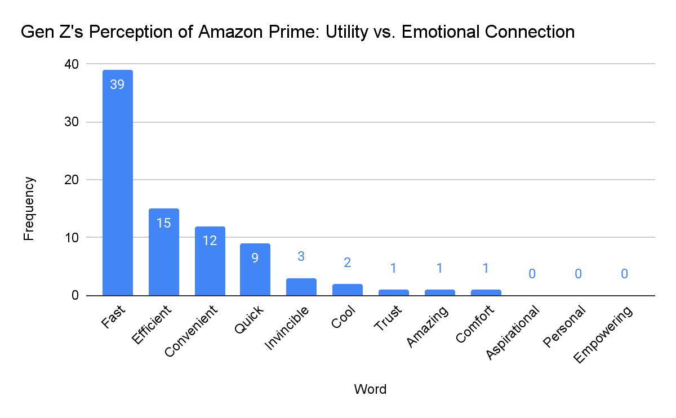
Chart 1: Gen Z’s Perception of Amazon Prime: Utility vs. Emotional/Personal Connection
(Based on responses to the survey question: When you think of Amazon Prime, what 3 words come to mind?)
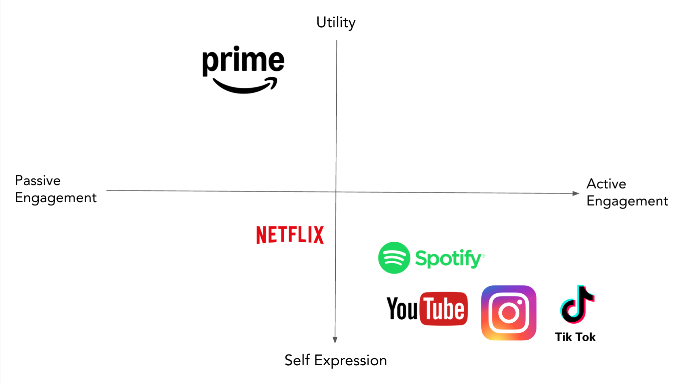
Chart 2: Perceptual Map: Amazon Prime vs. Competitor Brands in Utility and Self-Expression
(Based on responses to the survey question: When you think of Amazon Prime, what 3 words come to mind?)

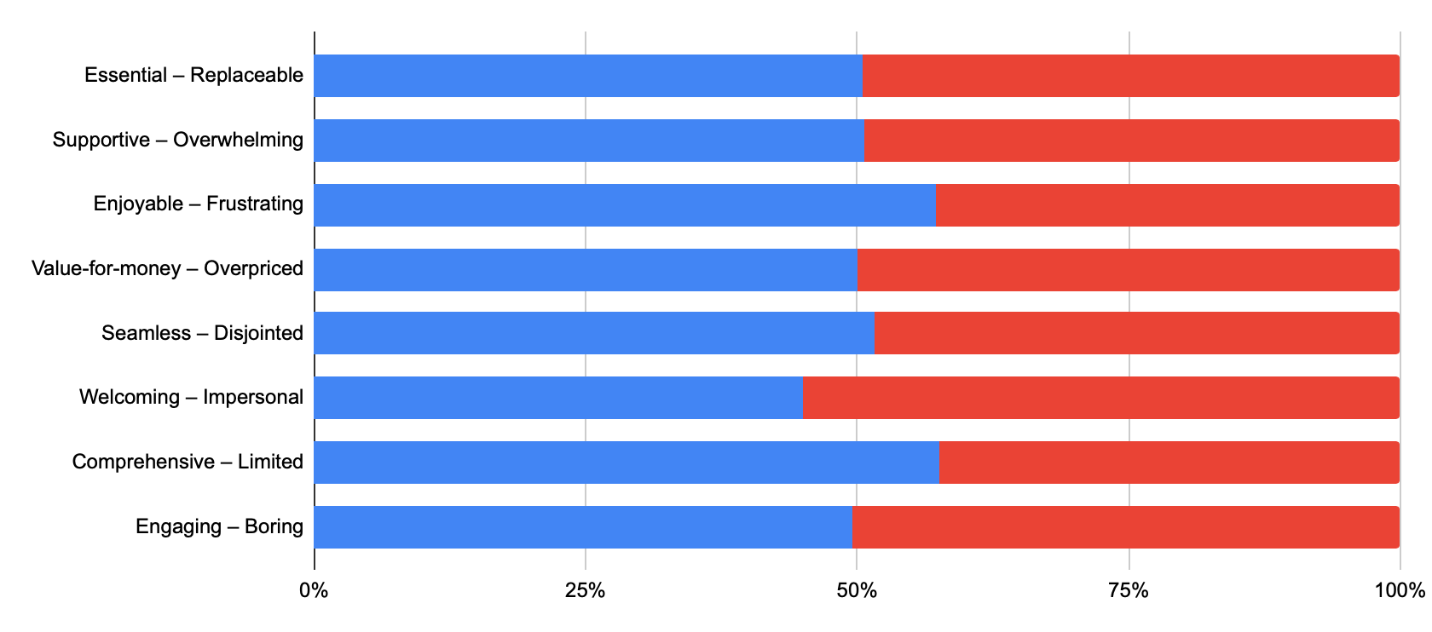
Chart 3: Semantic Analysis of Gen Z’s Perceptions of Prime Brand
(Based on responses to the survey question: For each pair of words below, select where your experience with Amazon Prime falls on the scale.)
1B. TARGET AUDIENCE  Define the audience you are trying to reach. Provide a clear definition and insight into your target audience. Talk about your audience’s attitudes and behaviors. Describe them using demographics, psychographics, culture, media behaviors, etc. Include attitudinal/ behavioral/ media consumption habits.  (Maximum: 150 words; 3 charts/graphs) | Effie Tips:  - Identify the audience and describe their attitudes, emotions, behaviors, culture, etc. – this is not the same as a demographic definition/description.  - Judges want to understand who the target is and what makes your idea the perfect way to reach them.  - Be sure to add new insights, rather than restating the directions or information provided in the assignment.  - Explain why this is the audience you are trying to reach and why this audience is important to the brand and the growth of the brand’s business?
Provide your answer.
Our target audience is U.S.-based Gen Zers aged 18–24, including both Prime account sharers and non-users. Gen Zers are digital natives who value personalized experiences and expect control over their services (McKinsey). Platforms like YouTube, TikTok, and Instagram play a key role in Gen Z's brand discovery, research and evaluation process (NielsenIQ). Since they are mostly in school or early in their careers, they rotate subscriptions based on budget, interests, and values, seeking brands that resonate with their passions and identities. While Amazon is recognized for being "fast," "efficient," and "easy" (Word Cloud), our data shows varying, but generally low, levels of attachment: on a 1-10 scale, Non-users rate Amazon significantly lower (1.75) compared to Owners (4.93) and Sharers (4.31) (Table 1). This indicates that while Gen Z values Amazon for its utility, there is an opportunity to foster deeper emotional connections beyond performance-based attributes.
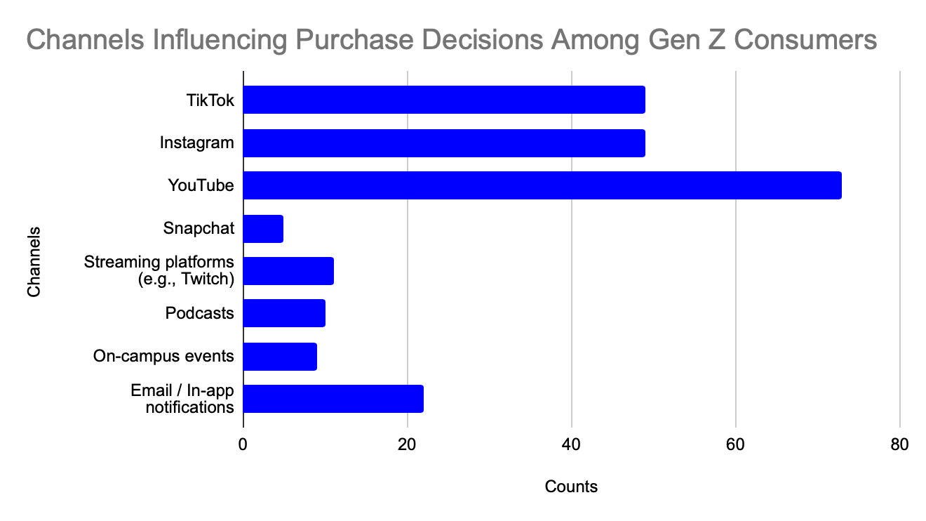
Chart 3: Channels Influencing Purchase Decisions Among Gen Z Consumers
(Based on responses to the survey question: Which of the choices below do you find helpful when deciding what to buy?)
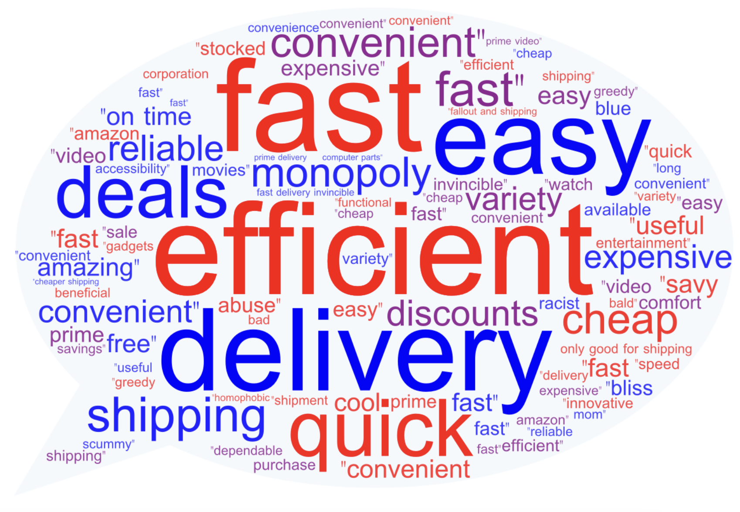
Word Cloud 1: Amazon Brand Perception Among Gen Z
(Based on responses to the survey question: When you think of Amazon Prime, what 3 words come to mind?)

User Type Vs. Attachment to Prime
User Type | Personal Attachment to Prime brand
Non-Users | 1.75
Owners | 4.93
Sharers | 4.31
Grand Total | 4.536585366

Table 1: Gen Z’s Attachment to Prime by User Type
(Based on responses to survey question: On a scale from 1 (not at all connected) to 10
(very deeply connected), how would you rate your personal attachment to Amazon Prime as a brand?)

1C. OBJECTIVES & KEY PERFORMANCE INDICATORS (KPIs)  What are your measurable objectives and why are they important for the brand? What are the Key Performance Indicators (KPIs) against your objectives?  Your entry may have one or all the following objectives:  A. Business, B. Behavioral, and/or C. Perceptual/Attitudinal. State specific objectives that apply to your case. Provide a % or # and timeframe for all objectives. Explain why these objectives are important for the brand.  (Maximum: 150 words; 3 charts/graphs) | Effie Tips:  - Make sure there are specific benchmarks to support your goals.  - Relate to the overall brand objectives.  - Objectives should align with the idea, media, and desired results.  - Be concise and straightforward, focus on addressing the challenge and driving business amongst the target audience.
Provide your answer.
To measure campaign success, we will track perceptual, behavioral, and business metrics. Perceptually, we aim to strengthen the association between Prime and user autonomy by increasing positive sentiment around personalization, targeting a 10% improvement in brand perception surveys and social sentiment within six months. Behaviorally, we seek a 15% increase in user engagement with personalization features, such as custom watchlists and recommendation fine-tuning, among existing users within three months. From a business perspective, we focus on converting campaign engagement into subscriptions, targeting an 8% increase in Prime memberships among 18-24-year-olds during the campaign period. By positioning Prime as a platform where Gen Z actively customizes their experience and identity, we aim to cultivate a sense of partnership, empowering users to take control of their choices and self-expression. This approach will drive new subscriptions, clearly demonstrating the campaign’s direct impact on conversion and brand growth. KPI mockups are shown below.
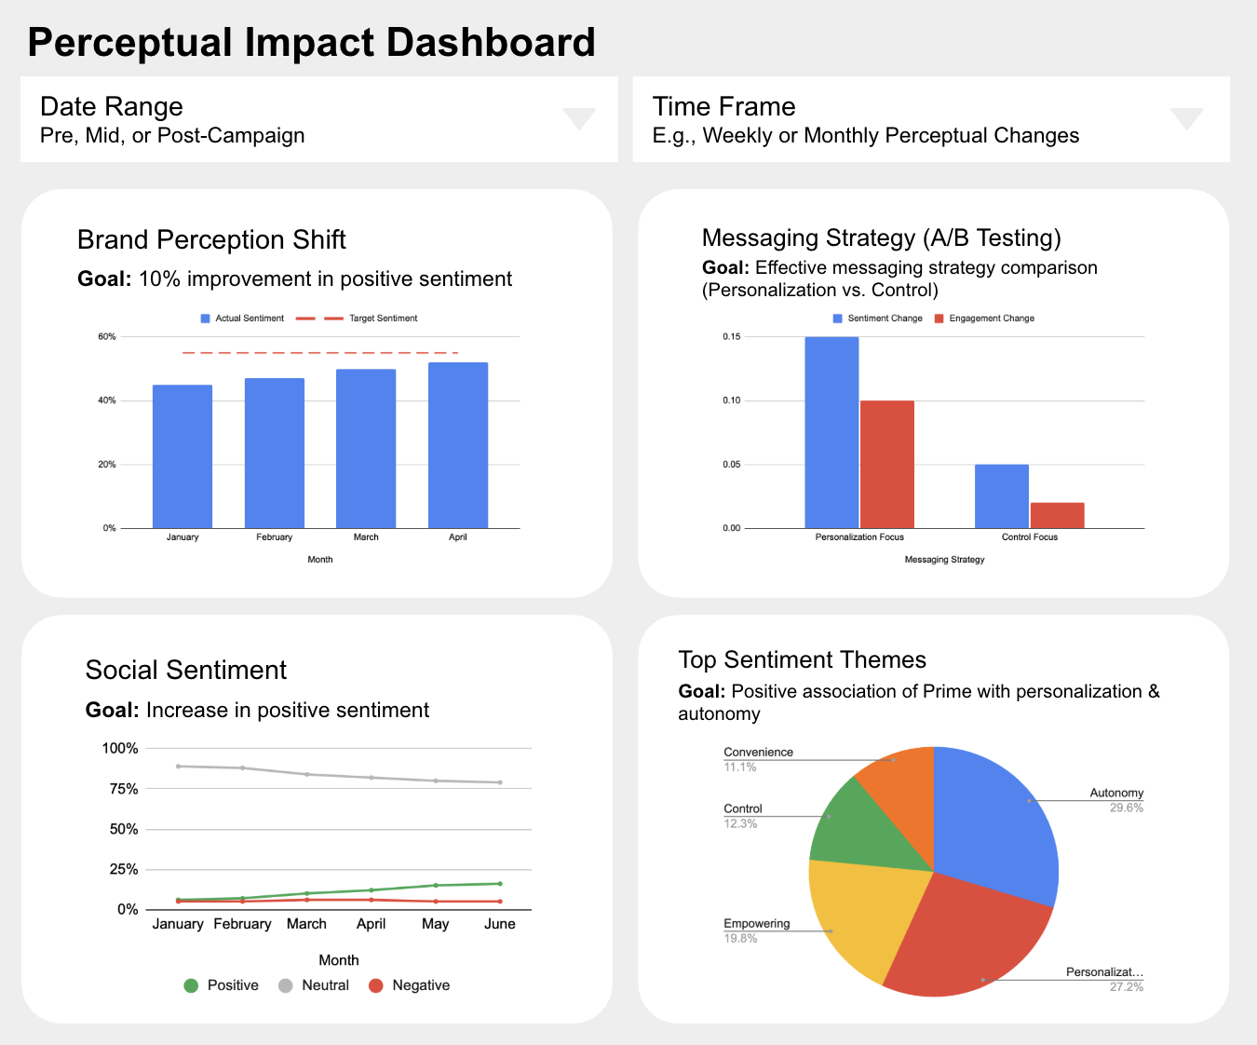
Chart 4: Mockup of Perceptual Impact KPI Dashboard
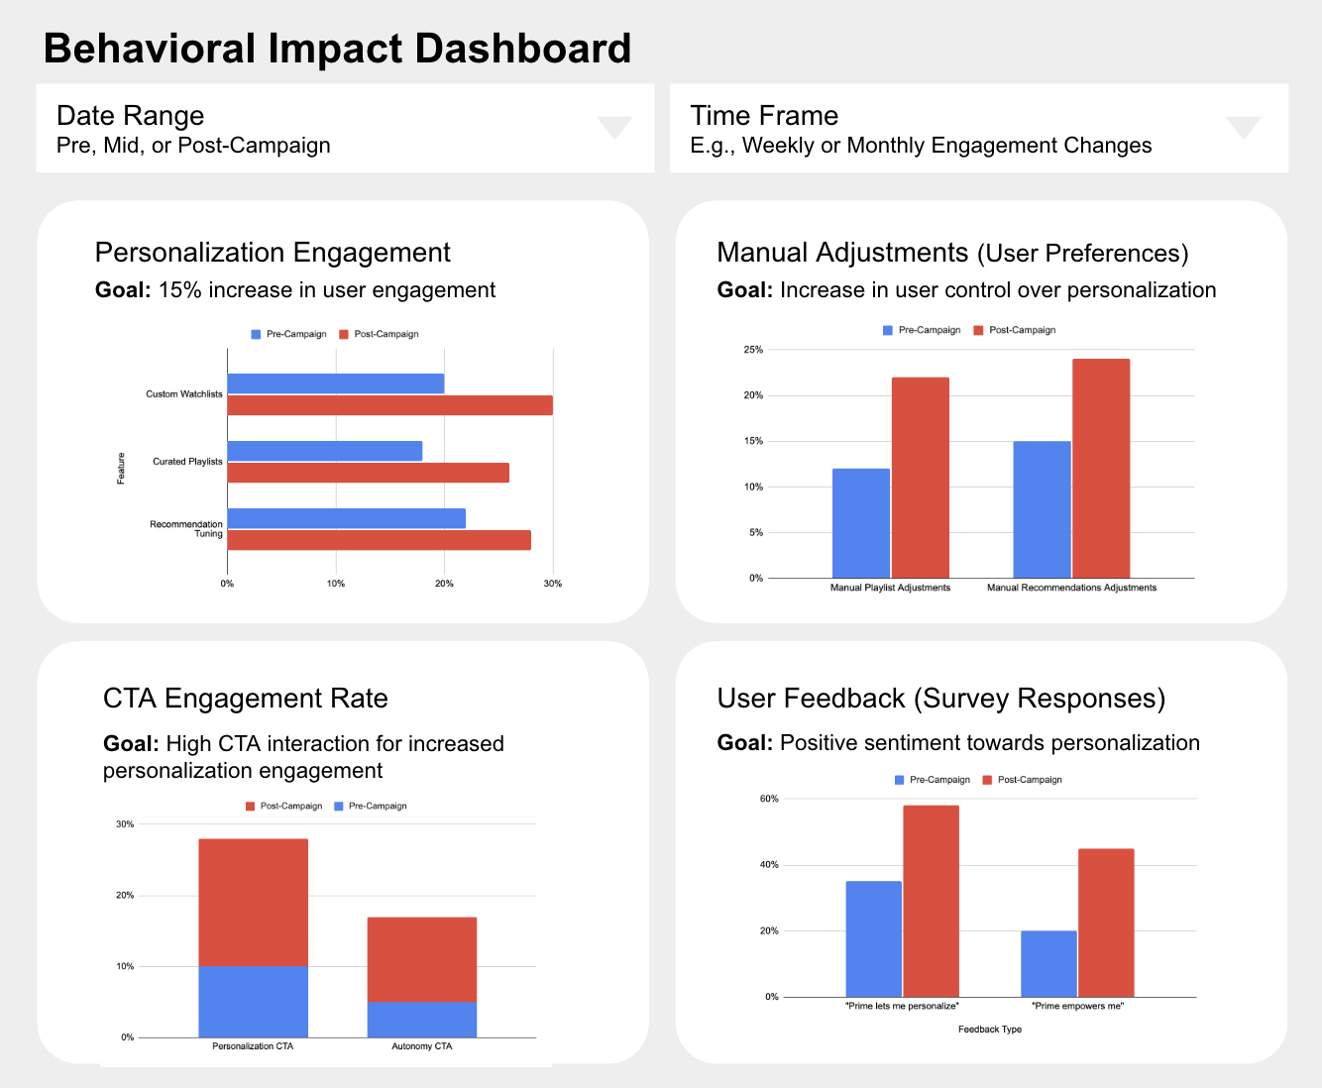
Chart 5: Mockup of Behavioral Impact KPI Dashboard
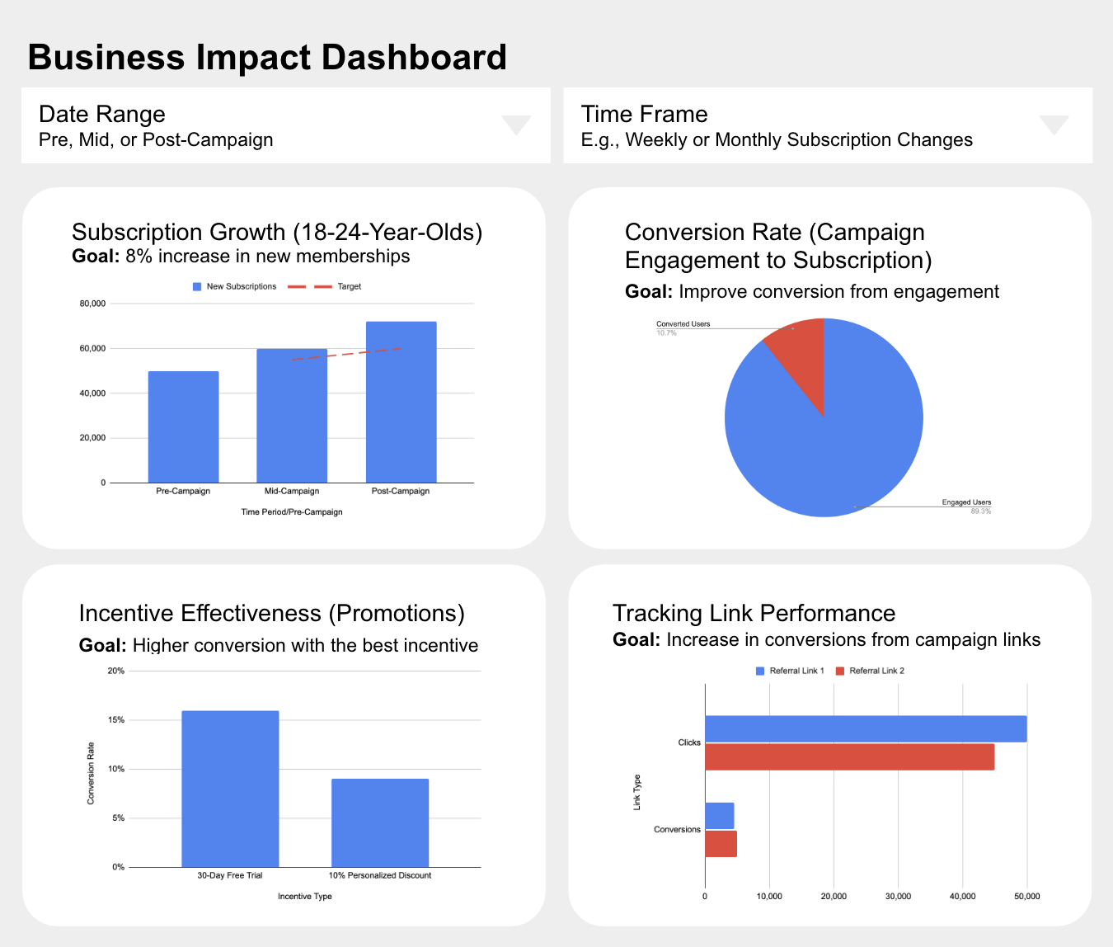
Chart 6: Mockup of Business Impact KPI Dashboard

SOURCES: SECTION 1  You must provide a source for all data and facts presented anywhere in the entry form.  SUGGESTED SOURCING LAYOUT: Source of Data/Research, Type of Data/Research, Dates Covered | - Use footnotes to provide sourcing information in each scoring section. Entrants are encouraged to use superscript to link data points to the footnotes provided below.  - Entrants are not permitted to outline additional information in the sources section. Entrants may only include the specific sources of data for the information presented in your responses to questions.
Provide sourcing.
Primary Data Sources
- Qualitative Interview Guide & Transcripts
- Quantitative Survey Data & Questions
Secondary Data Sources
- "How Gen Z Consumer Behavior is Reshaping Retail" (Nielsen, July 29 2024)
- "What is Gen Z" (McKinsey, August 28 2024)

SECTION 2: INSIGHTS & STRATEGY
25% OF TOTAL SCORE
This section covers the key building blocks of your strategy. Outline your key insight(s) and how they led to the strategic idea that addressed the business challenge the brand was facing. Your idea should be borne from these unique insights.

2A. INSIGHT  What was the insight that led to your idea? What observations led to your insight?  Explain: How was your idea driven by target audience insight. Detail any research that led to the insight or validated it. If there were media channel insight, timing opportunity, or other factors that informed the idea or plan, please highlight these in the relevant sections.  (Maximum: 175 words; 3 charts/graphs) | Effie Tips:  - Keep in mind, an insight is not merely a fact or observation based on research; it is the strategic insight unique to your brand and audience that was leveraged to help meet your objectives. Your idea should be borne from these unique insights.  - Explain how you arrived at your insight. Include how the target audience’s behaviors and attitudes and/or business situation led to the unique insights that will lead to the brand’s success and how those insights informed your idea.
Provide your answer.
Gen Z doesn’t want to be dictated by brands—they want to leverage brands to express themselves and control their own experiences. They seek partnership, not prescription.
This insight stems from survey data revealing that both Prime owners and sharers highly value autonomy and personalization, but only owners fully experience it. Among Prime owners, 53% are motivated by the desire for control and personalized use, with 59% drawn to affordable entry, such as student discounts (Chart 8). The survey also shows Gen Zers’ strong agreement with statements like “Having my own Prime account gives me more freedom and independence” (3.83) and “I like that I can personalize my experience without interference” (3.75), reflecting the importance of autonomy (Chart 7).
Among Prime sharers, 66% cite privacy concerns—particularly control over watch history, purchases, and payment details—as a top motivator for ownership (Chart 9). Additionally, affordability and personalization drive interest in converting to individual accounts. These insights validate that Gen Z seeks control over their experiences, which our campaign will emphasize by highlighting Prime’s autonomy features and offering affordable incentives to drive conversion.
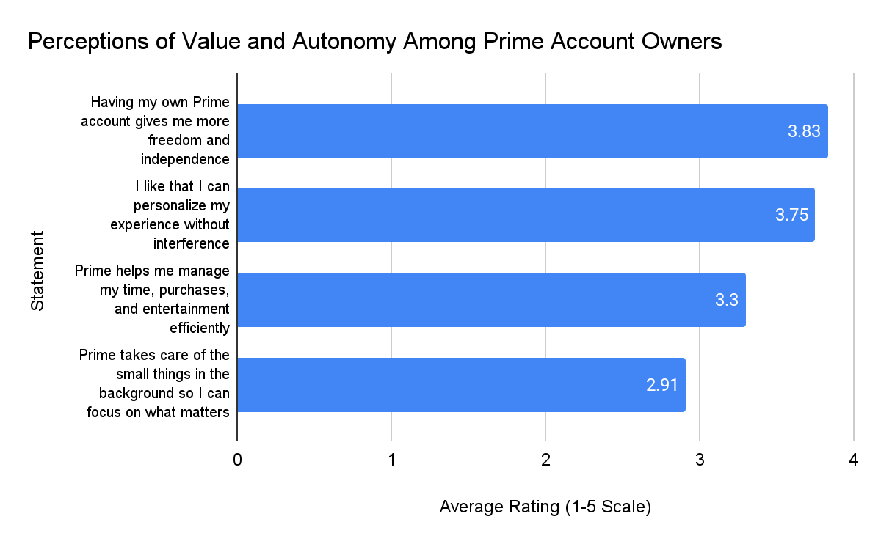
Chart 7: Perceptions of Value & Autonomy Among Existing Gen Z Prime Account Owners
(Based on responses to the survey question for Prime account owners: How much do you agree with the following?
(1 = Strongly Disagree, 5 = Strongly Agree)
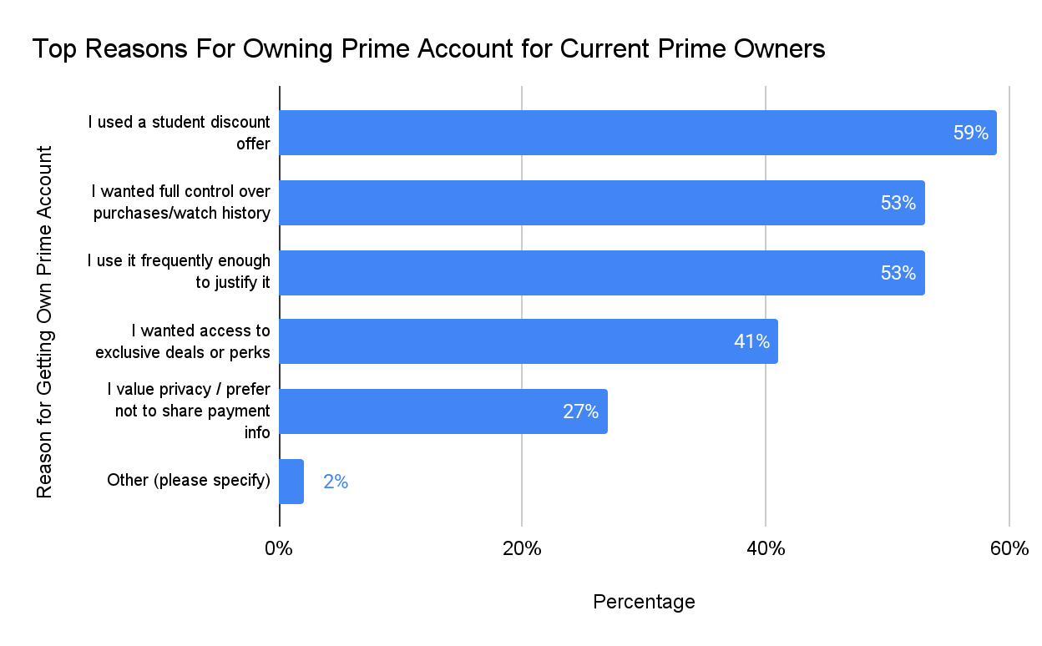
Chart 8: Top Reasons for Owning Prime Accounts for Current Gen Z Prime Account Owners
(Based on responses to the survey question for Prime account owners: Why did you decide to get your own Prime account? (Select all that apply)
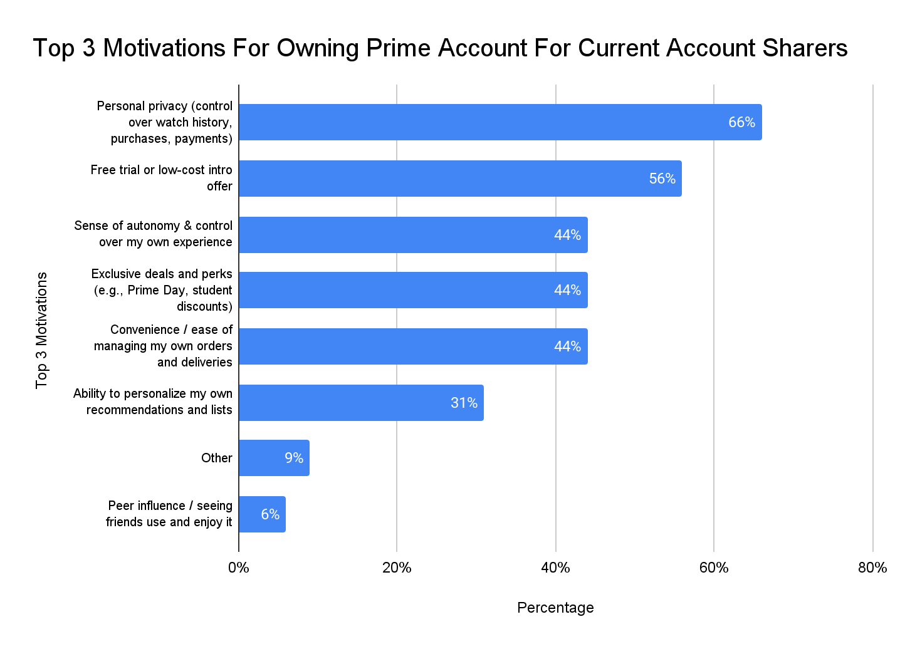
Chart 9: Top Motivations for Owning Prime Account for Current Gen Z Prime Account Sharers
(Based on responses to the survey question for Prime account sharers: What would most motivate you to get your own Prime account? Select Top 3.)
2B. STRATEGIC IDEA  In one sentence, state your strategic idea. What is the core idea or strategic build that will drive your effort (i.e., lead your communications strategy)?  (Maximum: One-Sentence: 20 words) | Effie Tips:  - Make sure the idea doesn’t regurgitate the objectives.  - What is at the very heart of this case? The idea should not be a tactic or a tone; the big idea is not the execution or tagline.
Provide a one-sentence answer.
Empower Gen Z with the freedom to personalize and control, seamlessly integrating Prime into their lives—on their terms, not ours.

SOURCES: SECTION 2  You must provide a source for all data and facts presented anywhere in the entry form.  SUGGESTED SOURCING LAYOUT: Source of Data/Research, Type of Data/Research, Dates Covered | - Use footnotes to provide sourcing information in each scoring section. Entrants are encouraged to use superscript to link data points to the footnotes provided below.  - Entrants are not permitted to outline additional information in the sources section. Entrants may only include the specific sources of data for the information presented in your responses to questions.
Provide sourcing.
Primary Data Sources
- Qualitative Interview Guide & Transcripts
- Quantitative Survey Data & Questions

SECTION 3: BRINGING THE STRATEGY & IDEA TO LIFE (EXECUTION)
25% OF TOTAL SCORE
This section relates to how you will translate your core strategic idea into a compelling creative platform and channel plan i.e. how and where you will bring your strategy to life. Judges are looking to understand why you chose specific media channels and how they relate to your strategy and audience. Judges will be providing their score for this section based on the information you provide in Question 3 and the creative work as presented in the creative reel and creative images. Between the creative examples and your response to this question, the judges should have a clear understanding of the creative work that your audience experienced and how the creative elements worked together to achieve your objectives.

3A. COMMUNICATIONS & MEDIA STRATEGY  How will you bring the strategy & idea to life? Explain your idea and your overall communications strategy.  Describe and provide rationale for your communications strategy that brings your big idea to life. Outline your  key channels choices and explain why you selected them. Demonstrate how your creative executions address the challenge. How do your creative and media strategies work together to reach your target audience?  Requirement: minimum of three (3) different creative executions via three (3) unique media channels.  (Maximum: 400 words; 3 charts/graphs) | Effie Tips:  - Tell judges how you will bring the strategy to life. Explain the creative idea and your overall communications strategy, as borne from the insights and strategic challenge described earlier.  - Tell the judges where you will bring the strategy to life and why you chose those channels. Why are your channel choices right for the target audience and idea?  - Why did you choose these channels and not others? Why are these right for your target audience?  - Creative executions must be in-line with objectives and strategic recommendations and tied back to business goals.  - Watch for inconsistencies between how you communicate your execution in the written case and how your case is presented in the video. The video and your written responses should complement one another.  - Refer to the “what we expect to see” section of the client brief for creative and media requirements/recommendations.
Provide your answer.
Our campaign will tap into algorithm-driven ad placements on several steaming and social media platforms such as YouTube, TikTok, and Spotify to show Gen Z just how little control they have over their digital experiences. These platforms are built on personalization, yet shared accounts and automated curation often distort what users actually want to see. Despite valuing highly customized experiences, Gen Z frequently finds themselves stuck with recommendations shaped by family members’ preferences rather than their own.
We’ll highlight this frustration by exposing how family-sharing on Prime leads to recommendations that don’t reflect them—whether it’s your sibling’s weird movie picks clogging Prime Video, your parent’s shopping habits influencing your Amazon suggestions, or your ex’s past purchases still haunting your feed. These moments aren’t just minor annoyances; they represent a larger issue—Gen Z’s struggle for autonomy in a digital landscape that’s supposedly built for them.
Unlike traditional campaigns that emphasize convenience or cost savings, our approach focuses on control—something Gen Z craves. They don’t want brands to tell them what they should like; they want the power to define their own experiences. This campaign shifts the narrative: instead of passively accepting whatever the algorithm serves, Gen Z should be the ones curating their world. Your watchlist. Your playlist. Your Prime, Your Way.
Through creative, platform-native executions, we’ll exaggerate these moments to make the lack of control feel undeniable. The message is simple: true independence starts with your own Prime account. Instead of feeling dictated by an algorithm, Gen Z should be able to shape their experience on their terms. By positioning Prime as a tool for self-expression rather than a one-size-fits-all service, we’ll emphasize its autonomy features and make individual plans feel like a no-brainer.
Since Gen Z already spends so much time on social media such as Tiktok and Instagram, as well as streaming services such as YouTube, Hulu, and Peacock, engaging with content tailored to them — our ads will meet them where they’re most aware of how algorithms shape their experience. These paid media placements will disrupt their usual content flow, engage users mid-listen, and prompt Gen Z to rethink how much control they really have—and why it’s time to take it back with Prime.
This campaign doesn’t just sell Prime—it reframes digital autonomy as a right, not a privilege. By making Gen Z feel empowered to take back control, we position Prime as more than a subscription—it’s a statement.
For campaign creatives, see.
Channel | Role in Strategy | Creative Execution | Why It Works for Gen Z | How It Aligns with Media Strategy
TikTok, Instagram, & YouTube (Pre-Roll & Mid-Roll Ads) | Intercept passive content consumption to reinforce the need for personalized control. | “Skip the Algorithm” Ads – Ads appearing before auto-recommended videos, calling out the algorithm: “The algorithm thinks you’ll like this. But what if you could decide for yourself?” | TikTok, Instagram and YouTube stand out as powerful channels for reaching and converting Gen Z (Statista, see Chart 10). | Contextually targeted placements ensure the message reaches users when they’re most aware of algorithm-driven recommendations.
Spotify (Interactive Audio Ads & Playlists) | Reinforce Prime as a customizable tool for personal experience curation. | “Your Prime. Your Playlist.” – Interactive audio ads both mid-roll and within podcasts that let users choose between two ad narratives, mimicking Prime’s personalization features. | Spotify as a touch point: Spotify’s dynamic ad format ensures they engage rather than passively listen. | Uses Spotify’s personalized listening behavior to highlight Prime’s superior customization capabilities.
Hulu / Peacock (Ad-Supported Plan) | Disrupt passive content consumption and reinforce the frustration of algorithm-driven recommendations. | Pre-roll & mid-roll ads showing how shared accounts ruin recommendations. Example: “Your dad's crime thrillers messing up your Hulu recs? Take control with your own Prime.” | Streaming touch point: Many Gen Z users opt for ad-supported streaming to save money, meaning they’re used to seeing ads but will engage if they feel personally relevant. | Hulu and Peacock rely on algorithmic content discovery, making them perfect platforms to highlight Prime’s personalization and autonomy- especially when Gen Z sees irrelevant content suggestions.
OOH (Billboards, Subway Ads, Campus Screens) | Capture attention in Gen Z hotspots with bold, snappy, relatable messaging. | Billboards in major cities & campuses: “My Prime thinks I need another cheetah top. Thanks Mom. Don’t let the familial algorithm control you — Your Prime, Your Way.” | Despite being digital natives, Gen Z values real-world experiences. Over 60% engage with interactive OOH ads—22% more than the general population. Nearly half follow advertisers on social media after seeing an OOH ad, and 38% make a purchase, proving its impact on engagement and sales (The Neuron, Outfront) | Creates offline reinforcement of digital campaign messaging, ensuring brand recall. Strategic placements near colleges, transit hubs, and entertainment districts maximize impact.

Table 2: Media & Channel Strategy

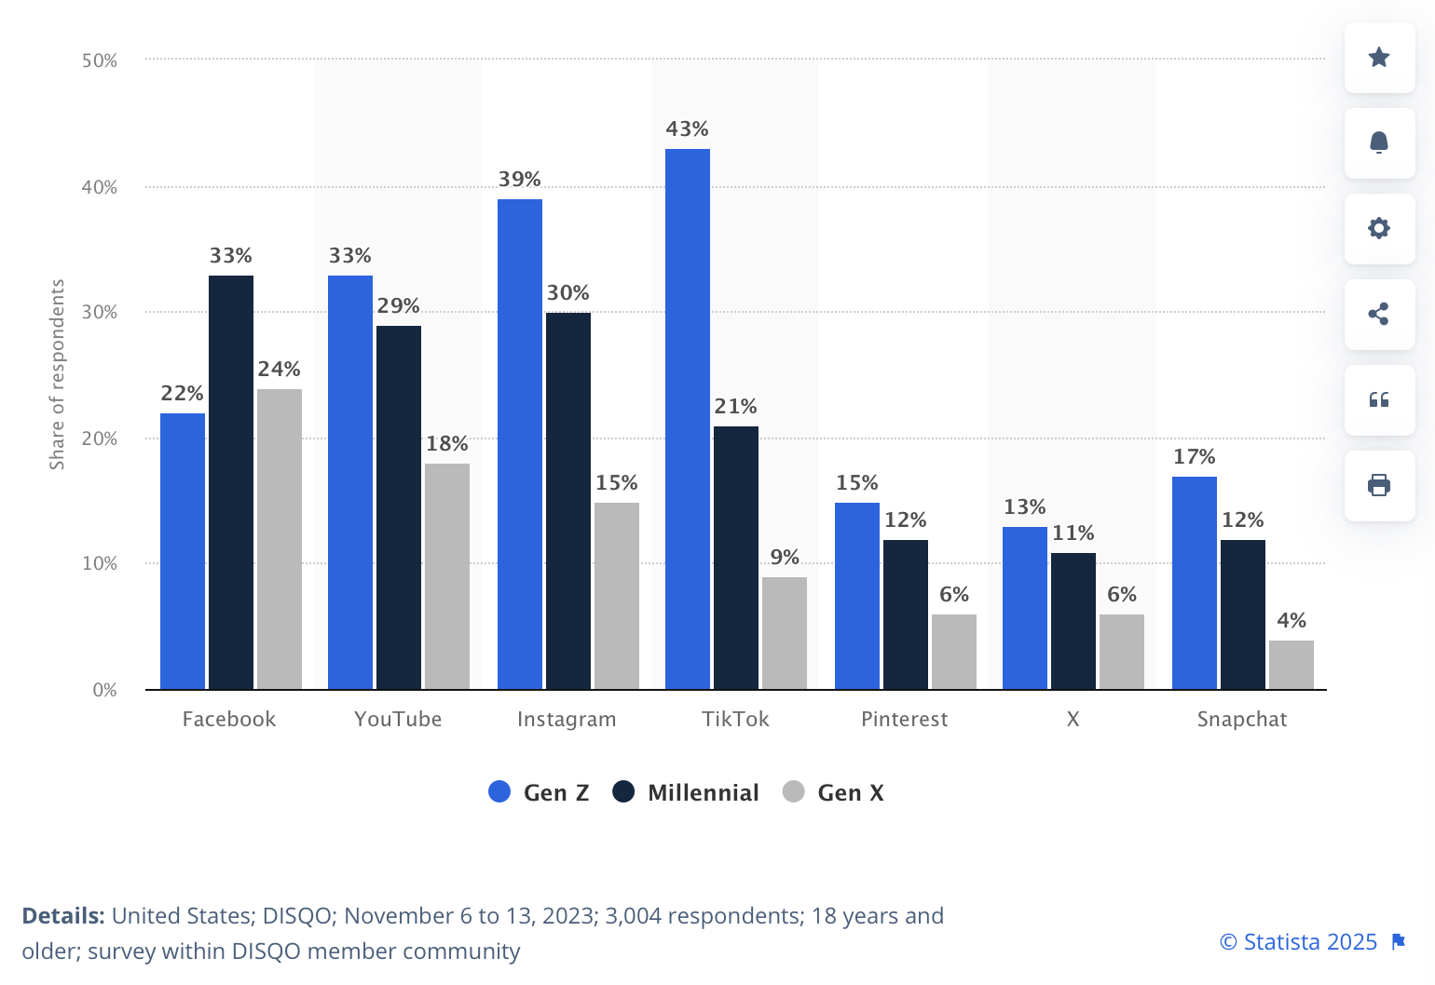
Chart 10: Social media platforms where consumers saw an ad that caused them to buy a product in the United States as of November 2023, by generation (Statista)

3B. BUDGET ALLOCATION  List the main communications touch points for your effort and estimate the percentage (%) of the total budget that will be allocated to each.  (Maximum: 100 words; 3 charts/graphs) | Effie Tips:  - Will your communications plan change over time? If so, explain how.  - Be sure to refer to the client brief for specific budget parameters.
Provide your answer.

Our campaign budget prioritizes TikTok (30%), Instagram (20%), and YouTube (20%) to interrupt passive scrolling with platform-native ads that subvert algorithmic influence. Spotify (10%) deepens personalization through immersive audio, while OOH (5%) delivers bold, attention-grabbing messages in high-traffic Gen Z zones. Netflix/Hulu (15%) leverages the tension of shared account culture within ad-supported streaming environments. By positioning Prime as a tool to reclaim algorithmic control and express individuality, the strategy aligns with Gen Z’s desire for autonomy. The allocation reflects platform engagement and conversion trends (Statista, 2024), maximizing relevance where algorithmic distortion is most keenly felt.

Touchpoint | % of Budget | Rationale
TikTok | 30% | It shows strong engagement among Gen Z consumers (Socialinsider, 2025) and leads in ad-driven conversions (Statista, 2024). Its short-form, native-style content is perfect for promoting Prime shows, features, or exclusive offers with high engagement and virality.
Instagram | 20% | Combining paid ads with influencer marketing maximizes Instagram’s impact. Influencers can showcase Prime as part of their lifestyle (e.g., binge-watching, shopping perks), while paid placements extend reach and retargeting capabilities.
YouTube | 20% | Great for storytelling via pre-roll and mid-roll formats, especially trailers, music videos or feature explainers. YouTube supports deeper content engagement and works well for building long-term brand recall among Gen Z (Search Engine Land, 2023).
Spotify | 10% | Spotify is highly popular among Gen Z, who make up half of its global listeners and spend over 2 hours per day on the platform (Spotify, 2024). Its ad-supported tier allows for personalized audio ads that feel native and engaging. It’s ideal for building brand awareness through immersive storytelling.
Netflix/Hulu | 15% | Netflix and Hulu receive 15% due to the premium cost of streaming video ads and the need for sustained visibility in long-form content environments.
OOH | 5% | It creates real-world visibility and complements digital efforts by driving social follow-through, driving offline-to-online conversion (Outfront, 2025). Great for promoting Prime as part of a lifestyle.
Table 3: Budget Allocation by Touchpoint & Rationale

SOURCES: SECTION 3  You must provide a source for all data and facts presented anywhere in the entry form.  SUGGESTED SOURCING LAYOUT: Source of Data/Research, Type of Data/Research, Dates Covered | - Use footnotes to provide sourcing information in each scoring section. Entrants are encouraged to use superscript to link data points to the footnotes provided below.  - Entrants are not permitted to outline additional information in the sources section. Entrants may only include the specific sources of data for the information presented in your responses to questions.
Provide sourcing.
Primary Data Sources
- Qualitative Interview Guide & Transcripts
- Quantitative Survey Data & Questions
Secondary Data Sources
- "Social media platforms where consumers saw an ad that caused them to buy a product in the United States as of November 2023, by generation" (Statista, July 17 2024)
- "2025 Social Media Benchmarks" (Social Insider)
- "How to Create Retargeting Ads on Facebook and Instagram" (Cyberclick, February 7th 2022)
- "Majority of Gen Z teens watch YouTube ads – almost half can recall campaigns" (Search Engine Land, August 29th 2023)
- "Marketing to Gen Z on Spotify" (Spotify)
- "Refuge in the Real: Why Gen Z Embraces OOH" (Outfront, March 20th, 2025)
- "Captivating Gen Z in Digital-Out-of-Home Advertising: Strategies for Success" (The Neuron, August 9 2023)

SECTION 4: MEASUREMENT METHODOLOGY (RESULTS)
25% OF TOTAL SCORE
This section relates to “results.” Be sure to explain the significance of your results as it relates to the brand. Tie back to the objectives outlined in Section 1. Charts/graphs to display data are allowed.

4A. MEASUREMENT METHODOLOGY  How do you know it will work?  Detail the measurement methodology that will be used to determine results. What tools will be used to measure the success of your effort. Refer to your responses in section 1. Make sure you address each objective. Indicate why the results you expect are significant in the context of your research. Source all research.  (Word Limit: 200 Words; 5 charts/graphs) | Effie Tips:  - How would you gauge results – looking for testing and performance methodologies.  - There needs to be a way to assess the effectiveness of the campaign against the set objectives using measurable benchmarks.  - Results need to answer the objectives – they shouldn’t be ambiguous.
Provide your answer.
For perceptual impact, we will conduct pre-, mid-, and post-campaign brand perception surveys to track sentiment shifts around Prime’s association with personalization and autonomy. Additionally, social listening tools like Brandwatch will monitor real-time social media sentiment, and A/B testing will assess the effectiveness of different messaging strategies in improving perceptions of the Prime brand.
For behavioral impact, we will assess changes in user interaction with Prime’s personalization features, such as custom watchlists on Prime Video, curated playlists on Prime Music, and recommendation fine-tuning on Prime Delivery. Engagement levels will be measured before and after the campaign, with a focus on how often users manually adjust preferences or engage with personalized content. We will also evaluate the effectiveness of campaign-specific CTAs that encourage users to take a more active role in shaping their Prime experience.
For business impact, we will track conversion rates using campaign-specific tracking links, referral codes, and first-party data from Prime sign-ups. A/B testing will compare effectiveness of different promotional offers, such as extended free trials versus personalized discounts, in driving subscription growth.
Through these methodologies, we aim to measure the campaign’s impact on perceptions, behaviors, and overall subscription growth, driving Prime’s relevance among Gen Z.
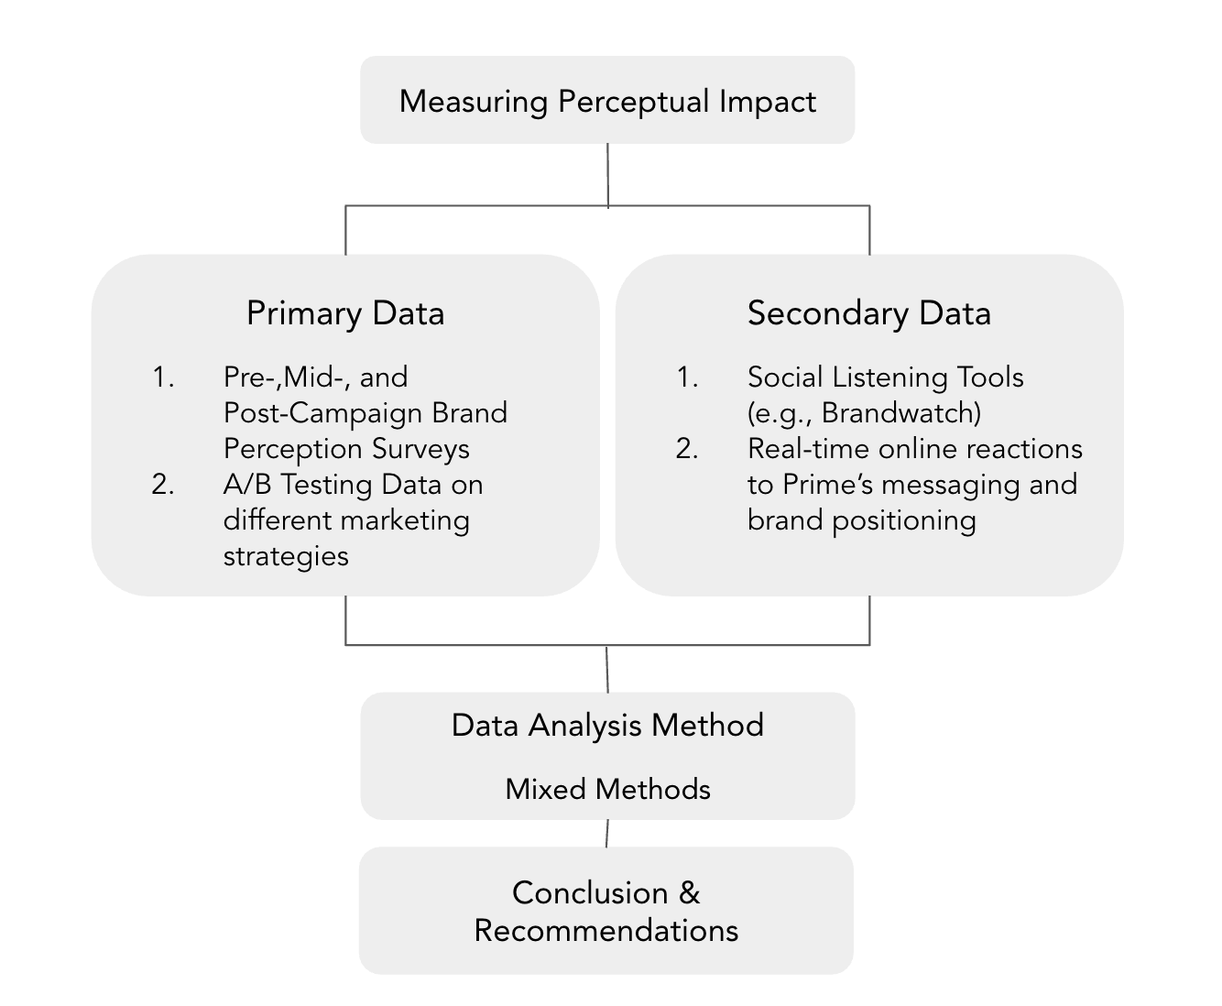
Chart 11: Measurement Methodology & Procedure for Perceptual Impact
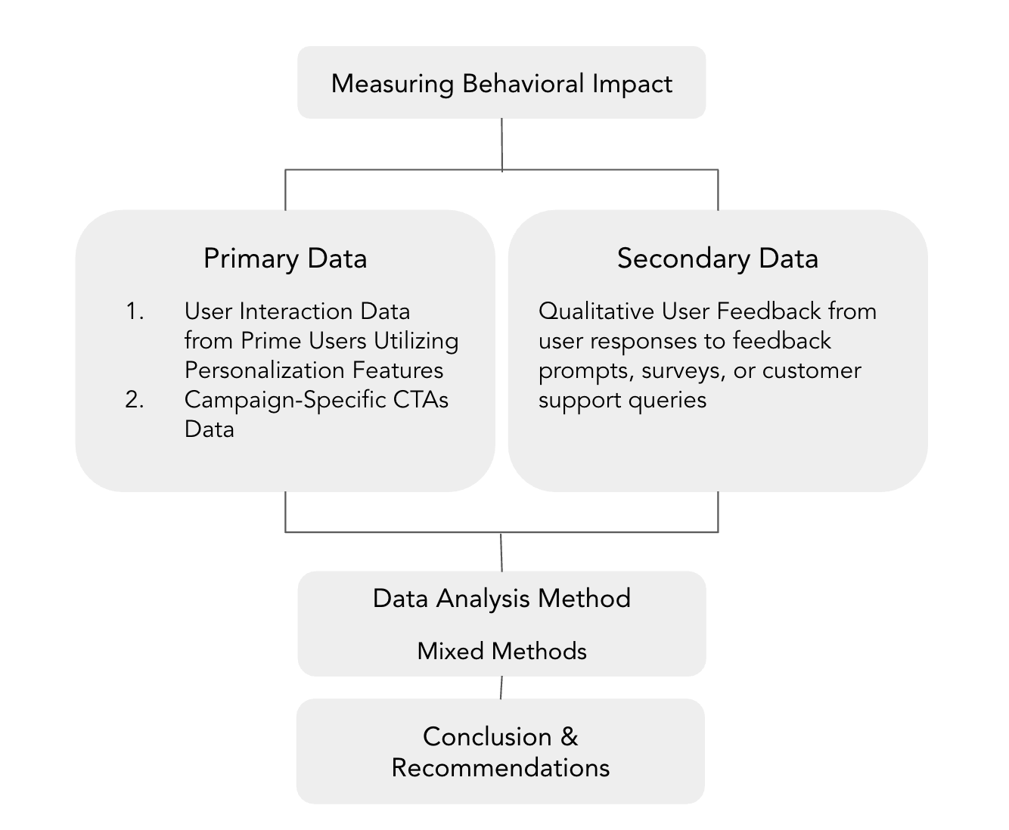
Chart 12: Measurement Methodology & Procedure for Behavioral Impact
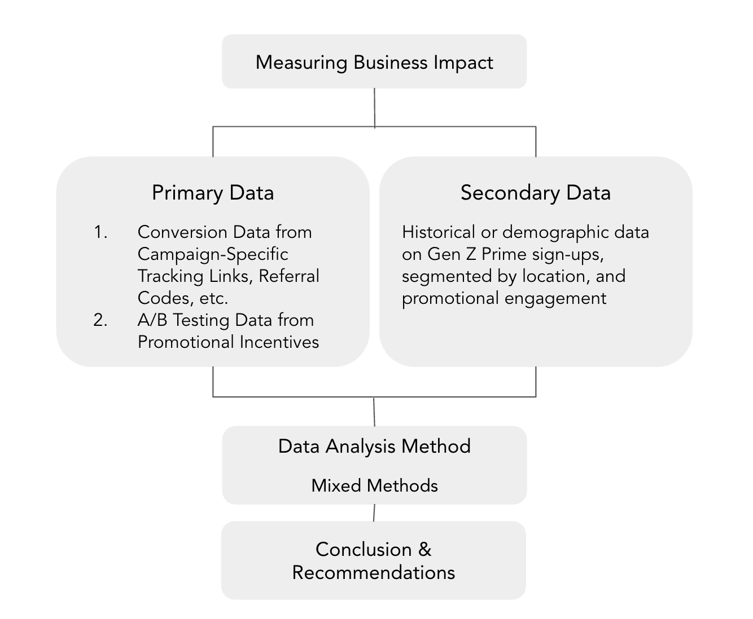
Chart 13: Measurement Methodology & Procedure for Business Impact

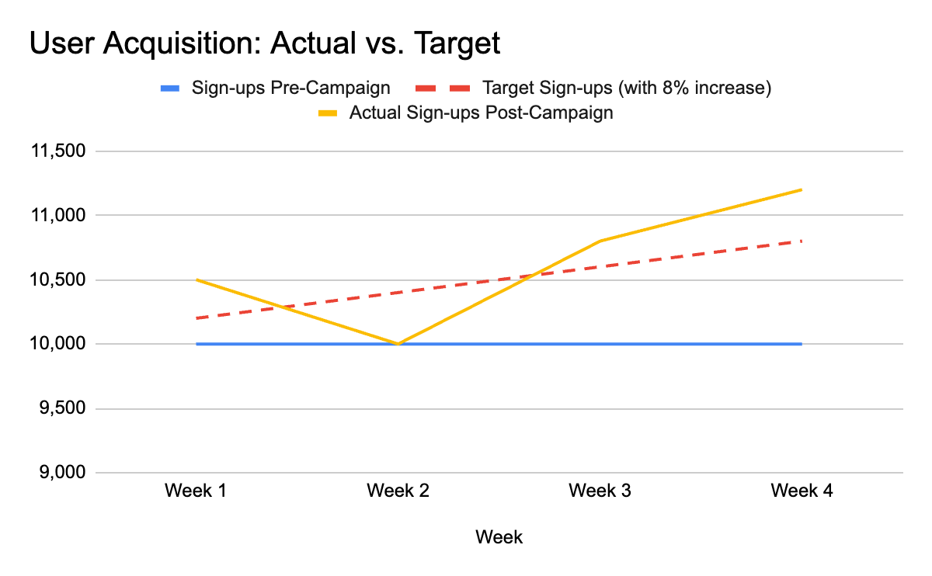
Chart 14: Mockup of User Acquisition Performance Pre vs. Post-Campaign
4B. BENCHMARKS  What are your pre/post measurable benchmarks?  (Maximum: 100 words; 5 charts/graphs) | Effie Tips:  - Have a measurement process. How do you know it will work? Give your statistics meaning.
Provide your answer.
For perceptual metrics, we aim to close perceptual gaps between Prime and top competitors like Netflix, which scores 3.83 vs. Prime’s 3.40 in brand perception on a 5-point scale (Bauhaus-Universität Weimar). We are also aiming for a 10% increase in positive sentiment post-campaign, consistent with Ad Awareness lifts of up to 17% seen in Prime campaigns in the past 5 years (YouGov, 2024). Behaviorally, users spend an average of 2 hours per day streaming on Netflix (the Verge, 2024). On the business side, we aim for an 8% lift in Gen Z trial sign-ups, with industry-standard opt-out trial conversion rates reaching up to 50% (Amplitude, 2024). Based on this benchmark, we can anticipate a potential 4% lift in paid subscriptions over time, indicating strong long-term impact as trial users convert to full members.
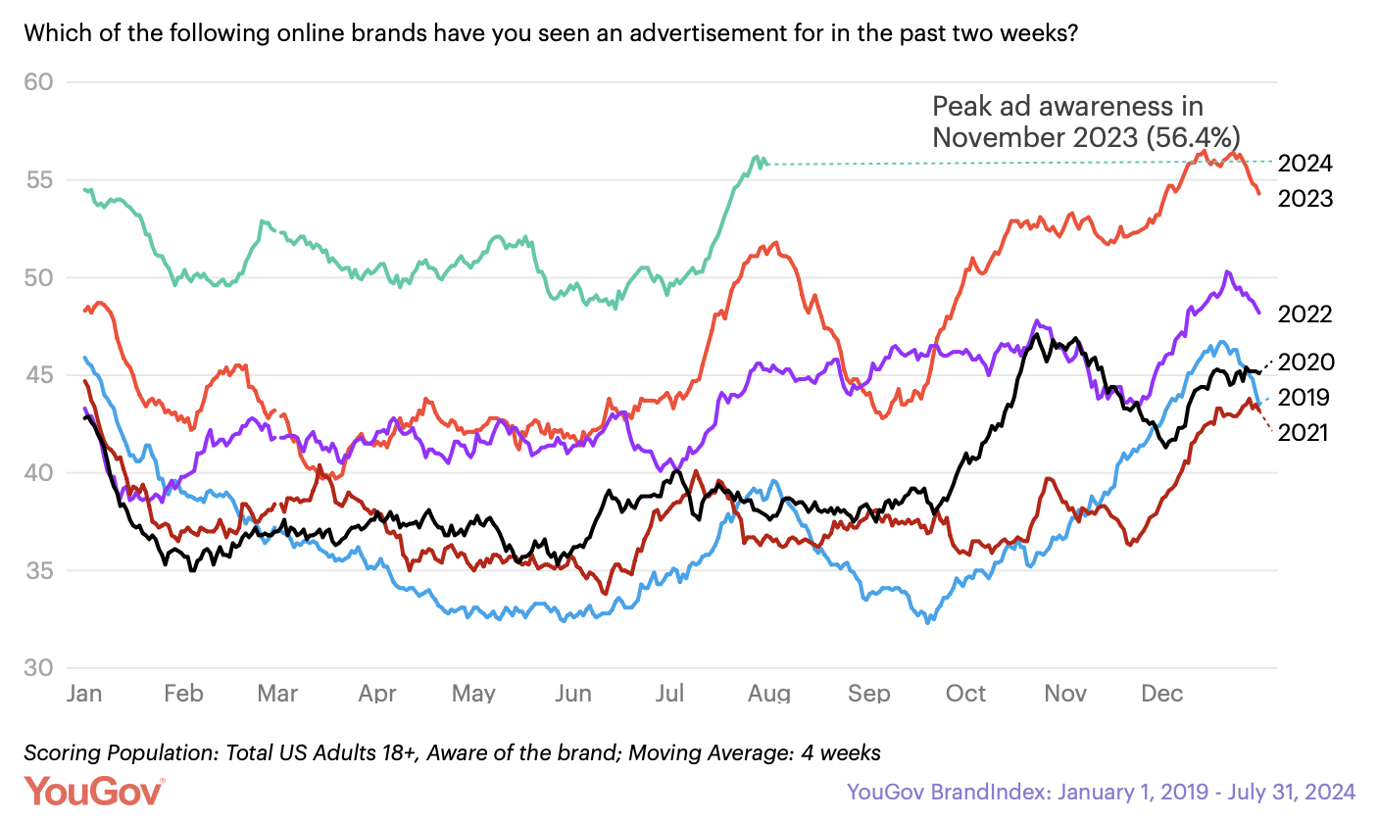
Chart 15: Amazon Prime Ad Awareness (2019–2024)

4C. POTENTIAL OUTCOMES  What are the potential positive/negative outcomes? Be sure to include any feedback you received from testing your creative work among focus groups.  (Maximum: 100 words; 5 charts/graphs) | Effie Tips:  - If you are going to point out the potentially negative impact of the campaign (which is honest and good), you should also provide a solution or a rationale to overcome it.  - All claims/facts/quotes presented must be sourced (using footnotes).
Provide your answer.
The "Your Prime, Your Way" campaign effectively highlights the issue of lacking control in the user experience journey, inspiring Gen Z to reclaim their digital autonomy. In addition to strong message clarity, with high scores for clear communication (YouTube 3.65, Paid Media Ad 3.73) and the notion of content control (Hulu 3.11, Paid Media Ad 3.23), the campaign successfully improves the brand perception and shifts the brand from utility-focused to more relatable, as seen in the word cloud, where emotionally resonant terms such as "trustworthy," "exciting," and "entertaining" finally rise to the surface. This shift reflects a deeper connection with Gen Z's values. Respondents also expressed personal resonance with the message, with statements like, "it felt personalized, they are addressing a real problem," and "I relate to mixing up feed and recommendations." These results demonstrate that the campaign resonated deeply with Gen Z, positioning Prime as a tool for regaining control.

Ad Type | The message of this ad was clear | The ad was engaging and held my attention. | This ad reflects feelings or experiences I personally had. | This ad helped me realize how I can have more control over my digital experiences. | I feel that Prime could offer me more control over my content recommendations. | After seeing this ad, I am more likely to get my own Prime account.
YouTube Ad | 3.65 | 3.52 | 2.83 | 3.26 | 3.04 | 2.26
Spotify Ad | 3.32 | 3.16 | 2.42 | 2.74 | 2.58 | 2.05
Hulu Ad | 3.26 | 3.05 | 2.79 | 2.84 | 3.11 | 2.68
Paid Media Ad (Gosling) | 3.73 | 3.18 | 2.55 | 2.96 | 3.23 | 2.36
OOH Ad (Mom) | 3.14 | 3.00 | 2.36 | 2.73 | 2.96 | 2.27
Table 4: Campaign Effectiveness by Ad Type
(Based on responses to the campaign testing survey question:
After seeing this ad, please rate your level of agreement with the following statements)
*Scale from 1 to 5, 1 = Strongly Disagree, 5 = Strongly Agree
Ad Type | Entertained: Indifferent | Motivated: Uninspired | Satisfied: Frustrated | Engaged: Bored | Excited: Disappointed | Relatable: Misunderstood
YouTube Ad | 3.57 | 3.48 | 2.81 | 3.29 | 3.05 | 2.24
Spotify Ad | 3.22 | 3.06 | 2.33 | 2.67 | 2.44 | 1.94
Hulu Ad | 3.33 | 3.17 | 2.89 | 2.94 | 3.22 | 2.78
Paid Media Ad (Gosling) | 2.14 | 2.50 | 2.00 | 2.05 | 1.95 | 1.55
OOH Ad (Mom) | 3.15 | 3.00 | 2.35 | 2.75 | 2.95 | 2.20
Table 5: Semantic Scale Analysis by Ad Type
(Based on responses to the campaign testing survey question:
What emotion best describes how this ad made you feel?)
*Scale from 1 to 5, 1 closely associated to positive emotion, 5 closely associated to negative emotion
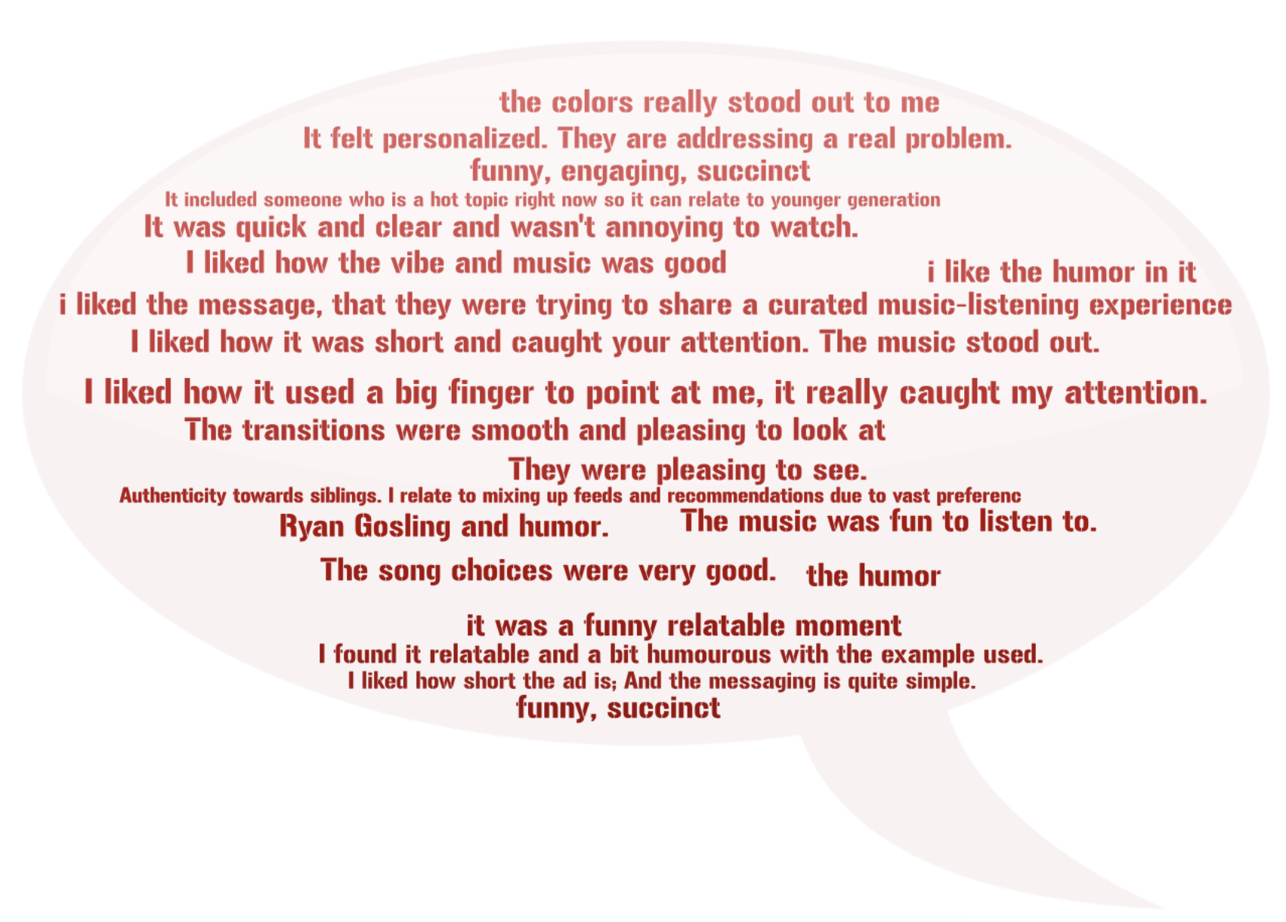
Word Cloud 2: What Survey Respondents Liked About Campaign Ad
(Based on responses to the campaign testing survey question:
What did you like most about this ad? (Free Response))

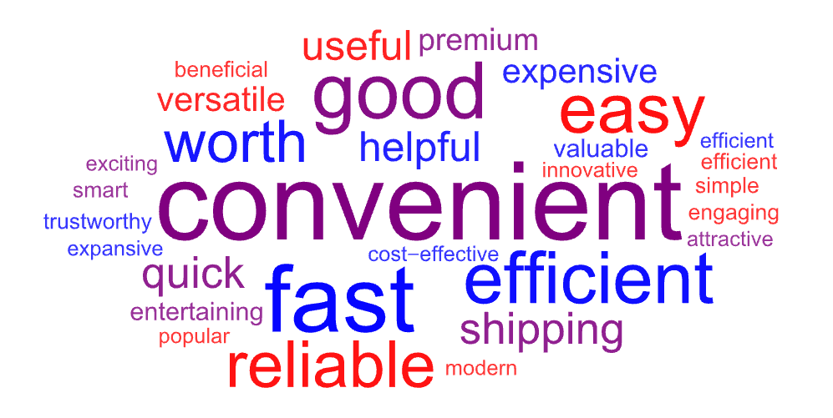
Word Cloud 3: Gen Z’s Perception of Prime Post-Exposure to Campaign
(Based on responses to the campaign testing survey question:
What words would you use to describe Amazon Prime?)

SOURCES: SECTION 4  You must provide a source for all data and facts presented anywhere in the entry form.  SUGGESTED SOURCING LAYOUT: Source of Data/Research, Type of Data/Research, Dates Covered | - Use footnotes to provide sourcing information in each scoring section. Entrants are encouraged to use superscript to link data points to the footnotes provided below.  - Entrants are not permitted to outline additional information in the sources section. Entrants may only include the specific sources of data for the information presented in your responses to questions.
Provide sourcing.
Primary Data Sources
- Qualitative Interview Guide & Transcripts
- Quantitative Survey Data & Questions
- Campaign Testing Survey
Secondary Data Sources
- How users approach novel media products: Brand perception of Netflix and Amazon Prime Video as signposts within the German subscription-based video-on demand market (Rahe et al., June 17 2020)
- "Amazon Prime Day 2024 boosts growth despite increased competition" (YouGov, August 30 2024)
- "Netflix says subscribers spend two hours a day on the platform" (The Verge, October 17 2024)
- "The Complete Guide to Increasing Free Trial Conversion" (Amplitude, August 16 2024)

